This is conceptual modeling language we will need to incorporate the content for natural language (from the template of architecture design document)

1.0 Introduction

|  |
| --- |
| (Points to cover)  - Business objective of project - Problem that the market is facing and is faced by clients - Challenges identified by the developers, strategists (solved by solution we are providing) - Componenets (Bundles) of ESB consumed/produced by application - Connectivity & Document transformation (data type, file format) - Feature sets of the application - Below We will document the solution oriented references in the three perspective - data perspective, functional perspective and behavioral perspective |

2.0 Solution oriented documentation

## 2.1 Data Perspective

Entity-Relationship models and class diagrams for documenting requirements in the data perspective

### Enhanced Entity-Relationship Model

In the following, we briefly describe the key concepts of the enhanced entity relationship (EER) model. Elements of the standard ER model are e.g., entity types, relationship types, attributes roles, and (simple) cardinality constraints. For detailed introduction to ER/EER model, we refer to [Elmasri and Navathe 2006]

#### Entity Type

The Entity type "MONEY LINE USER" represents all Moneyline user.

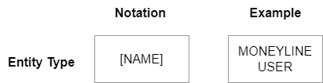

#### Relationship Type

A relationship type relates two or multiple entiy types. The relationship type "RECIEVES" between the entity types "MONEY LINE USER" and "DETAILS OF CHARGES"

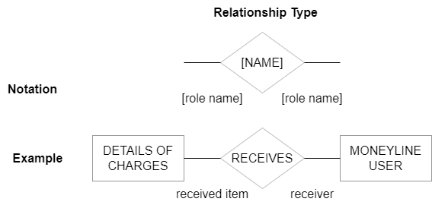

#### Attribute

An attribute defines property that is relevant for the system. The graphical notation of attributes in an EER model including multi-valued and composite attributes is depicted below

In the figure, account type is defined as a multi-valued attribute, since moneyline user may have more than one account type. The attribute "account no." is a composite attribute that consists of attributes, "residency address", "employement status", "marital status"

The figure abovedepicts an example of an attribute of a relationship type. For the relationship type "RECEIVES", the single attribute "Lending period" is defined. Defining the lending period as an attribute of the relationship "RECEIVES" allows for lending periods that are determined by the specific combination of Details of charges and Moneyline user.

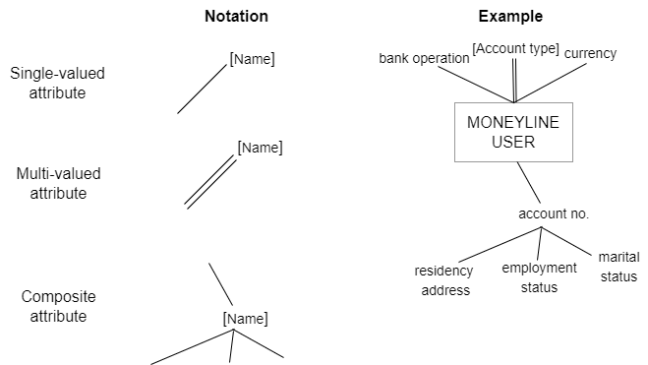

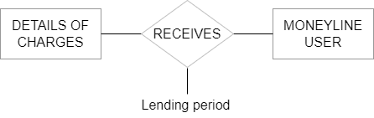

**Cardinality Constraint**

A cardinality constraint restricts the permissible number of entities that may participate in a defined relationship type. The (min, max) notation is used for defining cardinality constraints.  
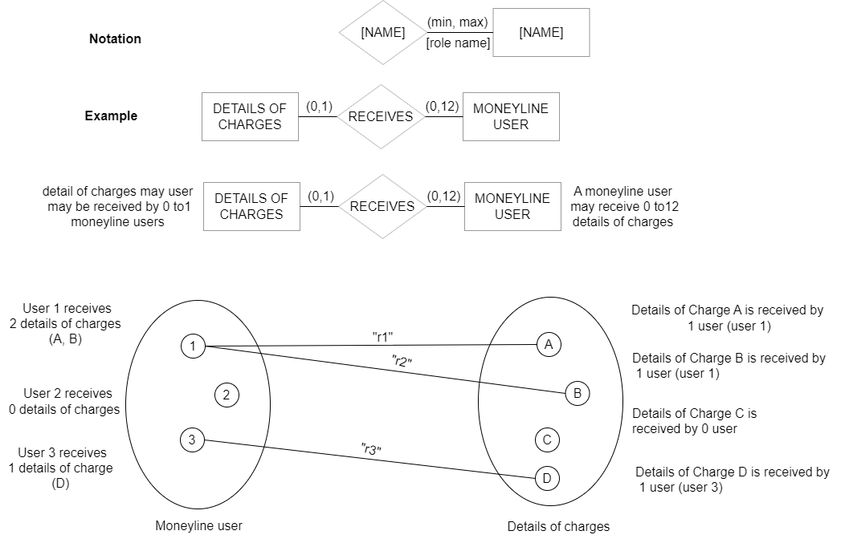

### Class Diagram

UML 2 class diagrams are used to document a system at different levels of abstraction. In this section we focus on use of class diagrams. Classdiagrams are used to document the static view of a system. A class diagram consists of a set of a classes and relationships between these classes.

#### Class

A class describes a set of objects which have a similar structure, a similar behaviour, and similar relationships. Objects have unique identity which means that two objects having same attributes are still distinguishable.

Figure depicts the class "Moneyline User". The class defines three attributes, "Account No.", "Employment status", "Currency". The operations compartment is empty since it is not defined yet at this stage.

If a class defines a structural element of the system, the required function of this element can be identified as operations, in operations compartment of the class.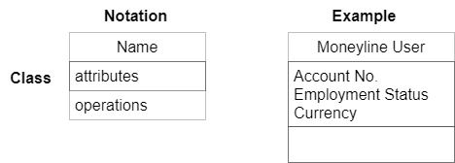

#### Attribute

Attribute are defined as line of text in attribute compartment of the class. The type, multiplicity, and property string are used for defining details about an attribute.

**Type**: The type of an attribute is denoted as a classifier such as class or a data type. The type restricts values that can be added to the attribute.

**Multiplicity**: The multiplicity consist of lower bound and an upper bound. It indicates the permissiable number of values that can be assigned to an attribute. An optional attribute has lower bound "0", A mandatory attribute has the lower bound "1", a single bound attribute has the upper bound "1", A multi-valued attribute has an upper bound greater than 1 or "*".

**Property String**: Examples of propert strings are [ordered], [unique], and [read only]. The property string [ordered] means, that value of this attribute are ordered according to some ordering ceriterion. [Unique] means each value of multi-valued attribute is unique. i.e., no two values are identical.[read only] means the attribute value cannot be changed.   
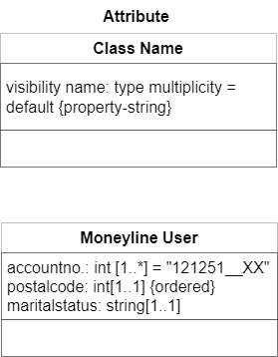

#### Association

Associations are used to relate classes to each other.

At each end of an association, a role, a multiplicity, and a propert string can be defined for the class attached at this end of the association:

- **Role**: The role name defines which role the class palys in this association.  
- **Multiplicity**: The multiplicity defines how many instances of the class at the correspponding association end can participate in the association. The multiplicity at an association end is defined in the same way as the multiplicity of an attribute. Examples of valid multiplicities are "0..1", "0..*", and "1..*"  
- **Property string**: The same proprrty strings acan be used for defining an association end as for defining an attribute. eg., of property string are [ordered], [read only] and [unique]

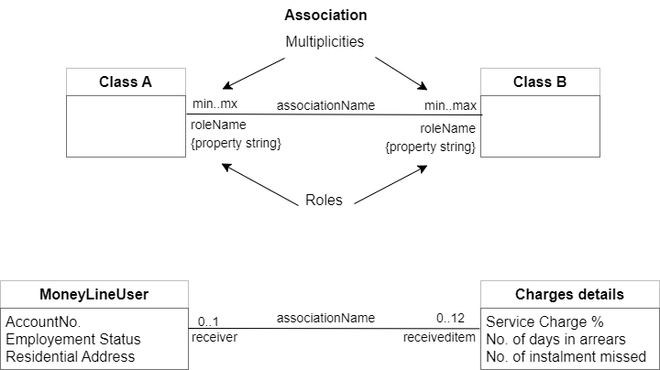

If the values of an attribute is not determined by a single class but depends on the relationship between multiple classes, this attribute can be defined as an attribute of an association class. An association class is both an association and a class at the same time. Therefore, an association class not only relates two or multiple classes but also defines attributes that characterise the relationships among these classes. The association class "Lending" is shown.

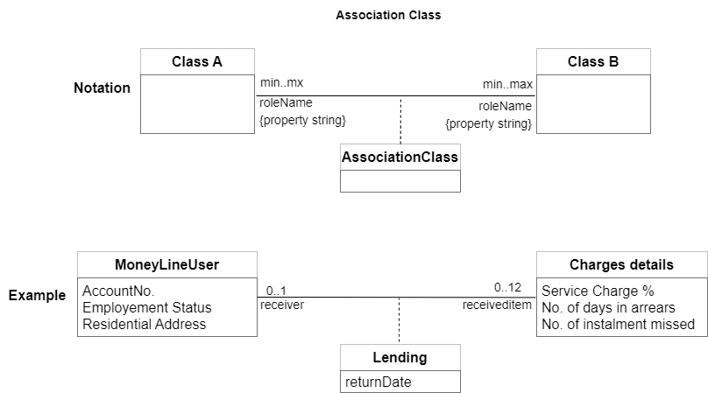

#### Aggregation and composition

There are two specific types of associations: aggregation and composition. Both describe the relationship between a whole and its parts. A composition documents a stringer form of whole-part relationship than an aggregation. A hollow diamond denotes an aggregation: a solid diamond denotes a composition.  
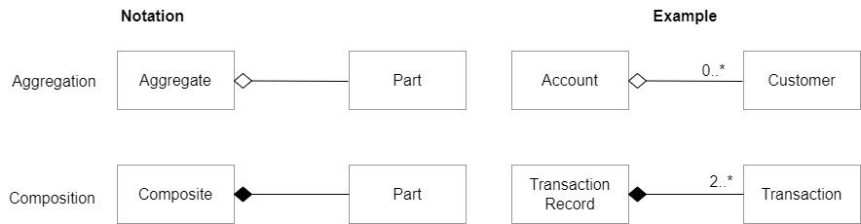

#### Generalisation

A generalization relationship relates a sub-class to a super-class. The sub-class inherits the attributes, operations, and relationships of the super-class. It may also define additional attributes, operations, and relationships and override the inherited attributes, operations and relationships.

The figure defines two sub-classes of the class "Reports": the class "Regulatory Reports" and the class "Pension reports", Since sub-classes inherit the attributes of the super-class, the classes "Regulatory reports" and "Pension reports" also have the attribute "unique"

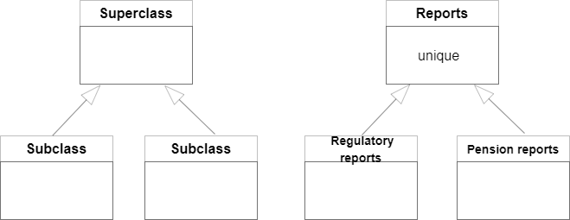

#### Abstract Classes

An abstract class has no direct instances. Abstract Classes are defined like ordinary classes yet the class name is written in italics.

In the example. an abstract super-class "receivableobject" is defined to represent all types of media that can be received from the moneyline.

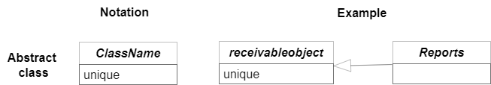

Object

An object is an instance of a class. It has concrete attribute values for each attribute defined by the class. An object is related to other objects by means of links. The links are instances of the associations of the class.

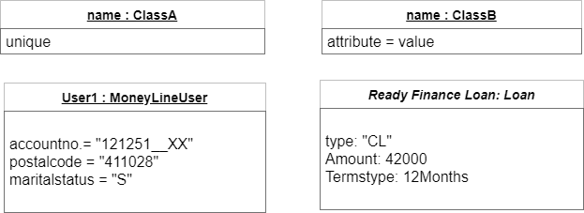

## 2.2 Functional Perspective

Data flow diagrams for documenting requirements in the functional perspective.

A functional model of a system documents requirements for the system in terms of functions, data flows of a system documents requirements for the system in terms of functions, data flows between the functions and data stores.

Data model documents data aspects such as entities and their relationships and attributes that are relevant for the system. A prominent approach for data modelling is the entity-relationship (ER) model see [Chen 1976]. The ER model was inspired by work on relational database models.

### Data Flow Models

A data flow model consists of a set of data flow diagrams, a data dictionary and mini-specifications. Below are the sub-sections as well as main concept.

#### Process (Function)

A process or function represents a task or activity that the system shall provide or implement. A process consumes some input data, processes the data and passes on to the result (the output data) to other process, a data source or a sink. A process hence transforms inputs into outputs.

Figure depicts two processes (functions) of the loan management system. The process "Calculate Service charge" calculates service charge from Day 0 to Day nth (where n is date of last instalment). The process "Track record" keeps track of instalment payments as per determined terms.

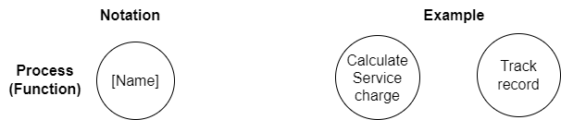

#### Source/Sink

Sources and sinks are external objects (e.g person, systems, departments, organization etc.) that communicates with the system through data flows.

A source passes data on to the system or to the processes defined for the system. A sink receives data from the system or from the processes.

A data flows between the system and the sources and sinks define the system interfaces. In Structured Analysis so called context diagram is used to define the system interfaces.

#### Data Store

A data store defines a repository of data. Data stores persistently record data in the system. The processes of the system can access the data in a data store (i.e they can read or write the data). The graphical notation of a data store in a DFD is shown.

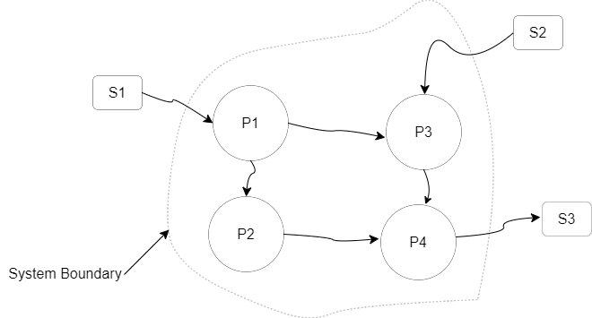

#### Data Flow

A Data flow describes the transportation of information packets of known composition. Hence, a data flow defines a stream of flowing data. In contrast, data store defines stationary data. A data flow can be defined between two processes, a process and a file as well as a source or sink and a process.

It is important to note that DFDs are not used to define control flows. A DFD des not provide any information about the time when the processes are executed. DFDs primarily shows the data dependencies of the processes and document the input data required by the processes and output data produced by the processes.

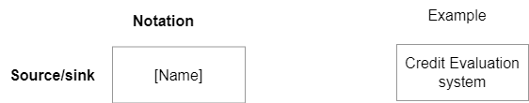

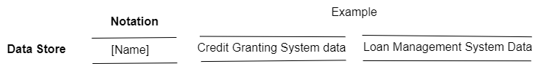

The Data flow "max. Credit score" from the source/sink "Credit Evaluation System" to the "Score Evaluation"  
The data flow "Sanction stage data" from the process "Track record" to the source/sink "Credit Evaluation System"  
The Data flow "match Credit score" from the process "Track record" to the process "Update score"  
The Data flow from the data store "Sanction Stage Data" from the process "Credit evaluation"   
The data flow "match gredit score from the process "calculate rpute" to the data store "Credit Granting System Data"

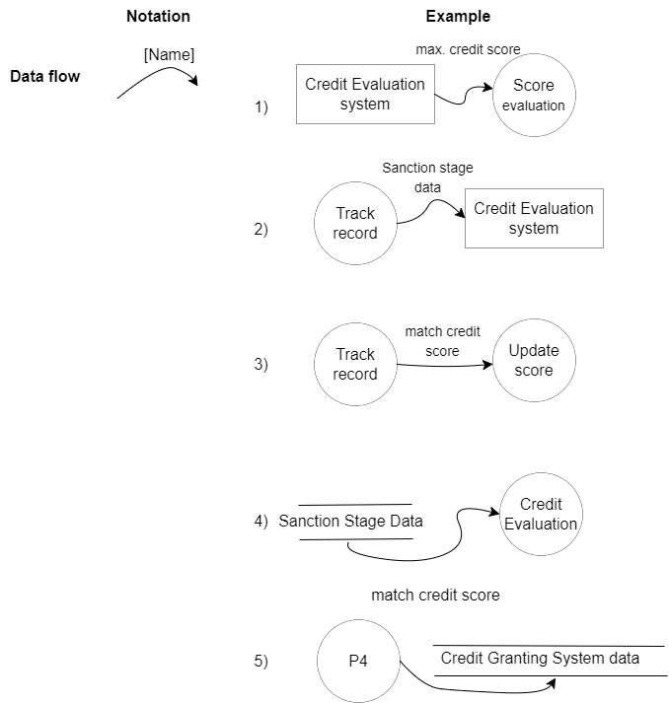

### Data Dictioanry

The data dictionary contains the definitions of the data flows. The data dictioanry is deined in parallel with data flow diagrams (DFDs).

### Mini Specification (Mini-Spec)

A mini-spec contains a concise description of a process. Each process defined in a DFD must be either defined by a mini-sec or refined b a lower level DFD.

A mini spec describes briefly (textual - content) how a process produces its outputs based on the inputs.

## 2.3 Behavioral Perspective

Behaviour models are used to document the reactive behavior of a system. Typically, the dynamic behavior of a system is defined using the following key concept:

1) **State**: A state defines a period of time in which the system behaves in a specific way and waits for the  
occurrence of a defined event that triggers a state transition.

2) **Event**: An event is a discrete incident in the world. The occurrence of an event is instantaneous. There are two types of events: External and temporal events. An external event is an event that occurs in the system environment and for which the system is expected to produce a response. A temporal event is triggered by reaching a specific moment in time which triggers the system to perform some action.

3) **State transition**: An event triggers a state transition> A state transition describes a change in the state of the system. i.e. the system changes from its current state into other state.

#### Finite Automata

based on [Hopcroft et al. 2007] A finite automation consists of a finite set of states and a finite set of transitions.An automation is called deterministic if, for each state and for each event, at most one state transition is defined. An automation s called non-deterministic if for at least one state multiple transitions are defined for at least one event.

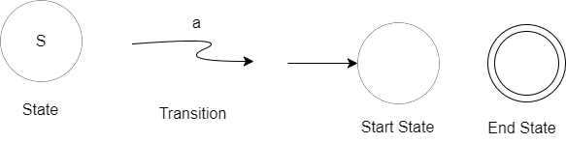

#### State Chart

To overcome some problems encountered when using finite automata for defining the behaviour of real software systems, statechart modeling language was developed. Key enhancements offered by statecharts.

1) Defining actions for states and transitions  
2) Defining conditional transitions  
3) Hierarchical refinement of states  
4) Modelling concurrent behaviour.

Defining actions for states and transitions

Statechhart facilitate the definition of actions the system shall execute

1) When performing a state transition  
2) on entering a specific state  
3) while being in the state  
4) When leaving a state.

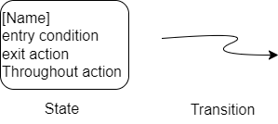

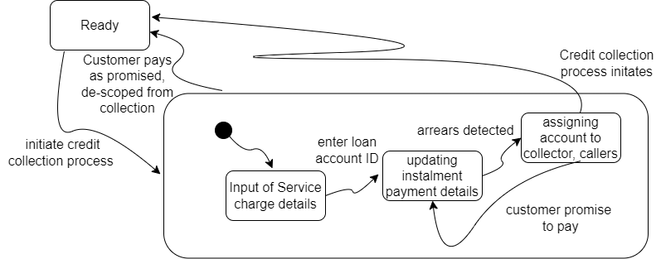

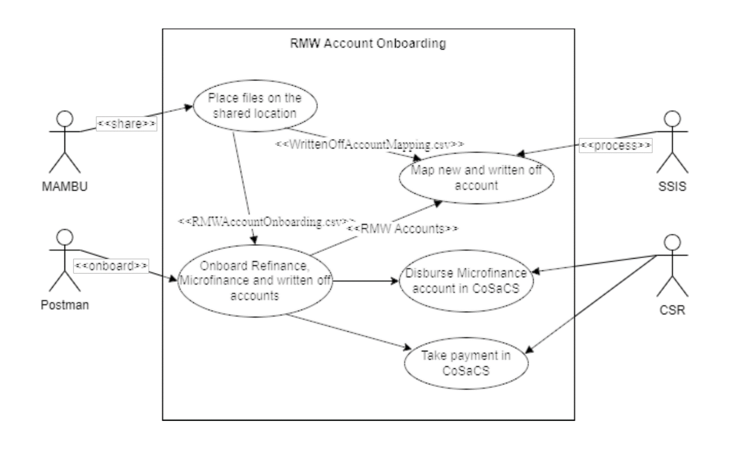

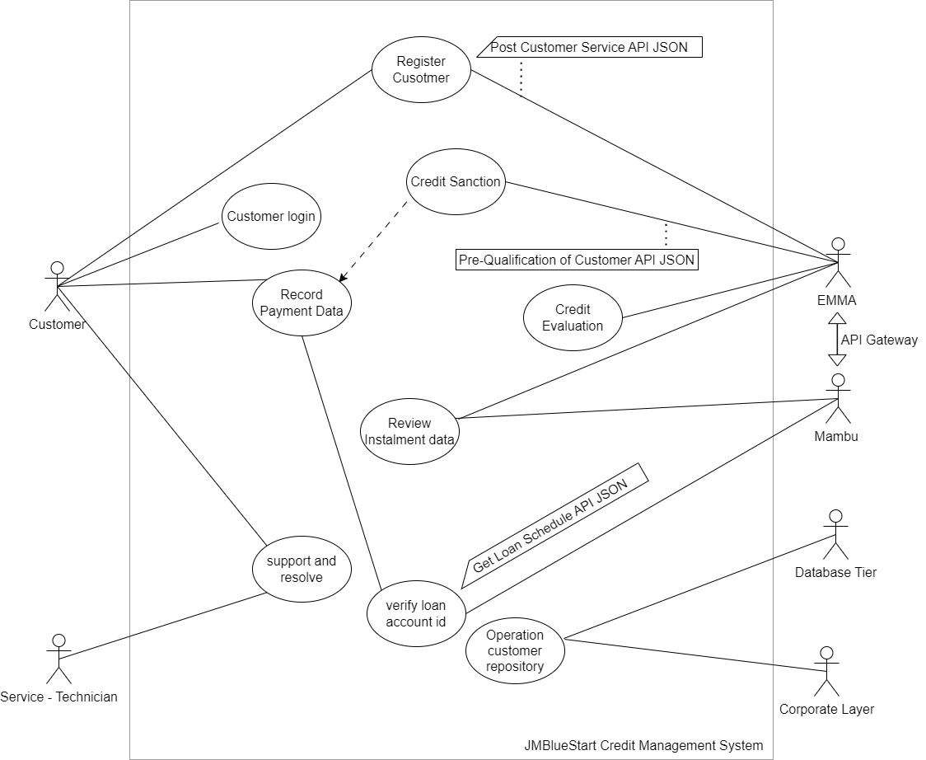

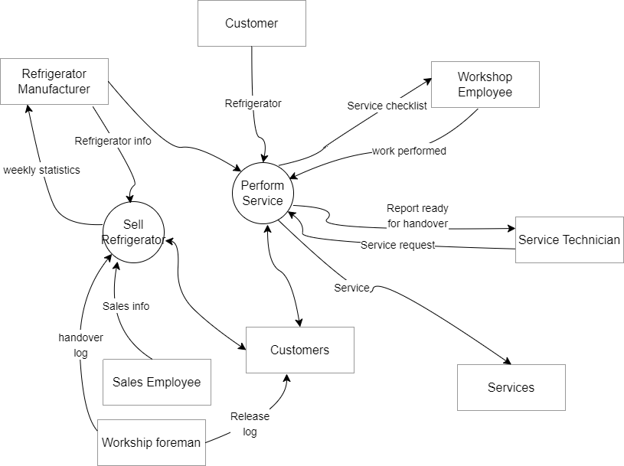

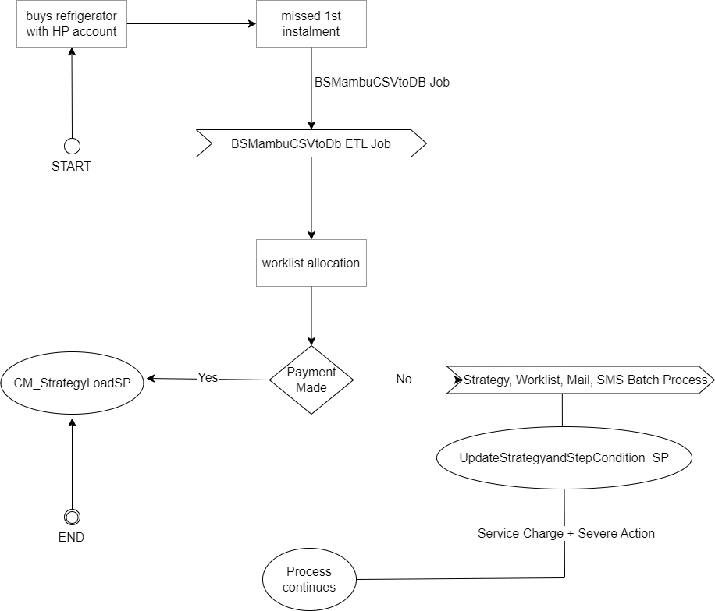

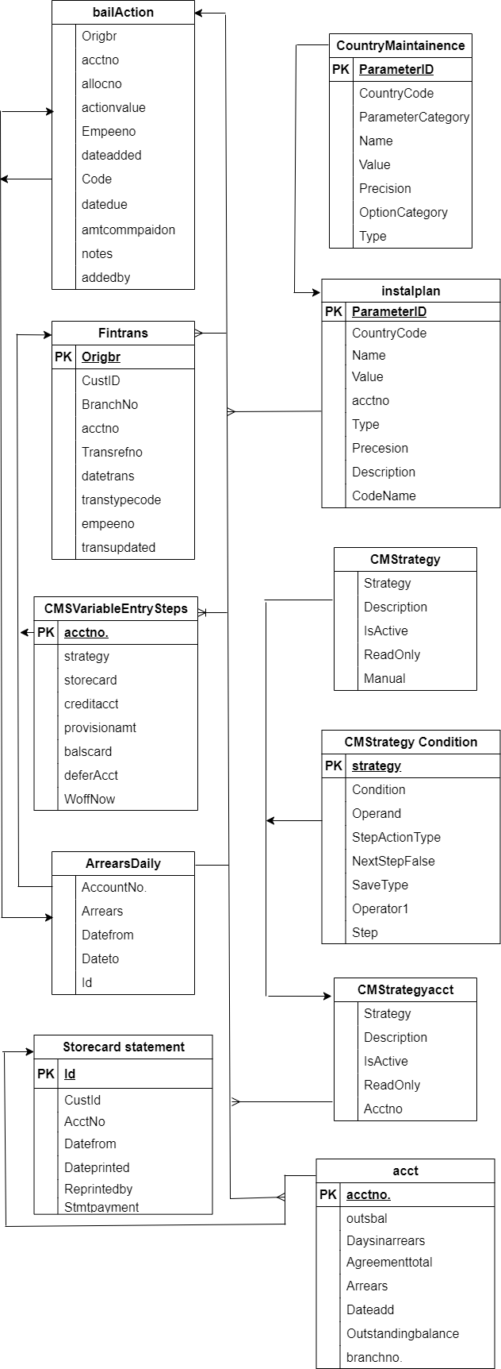

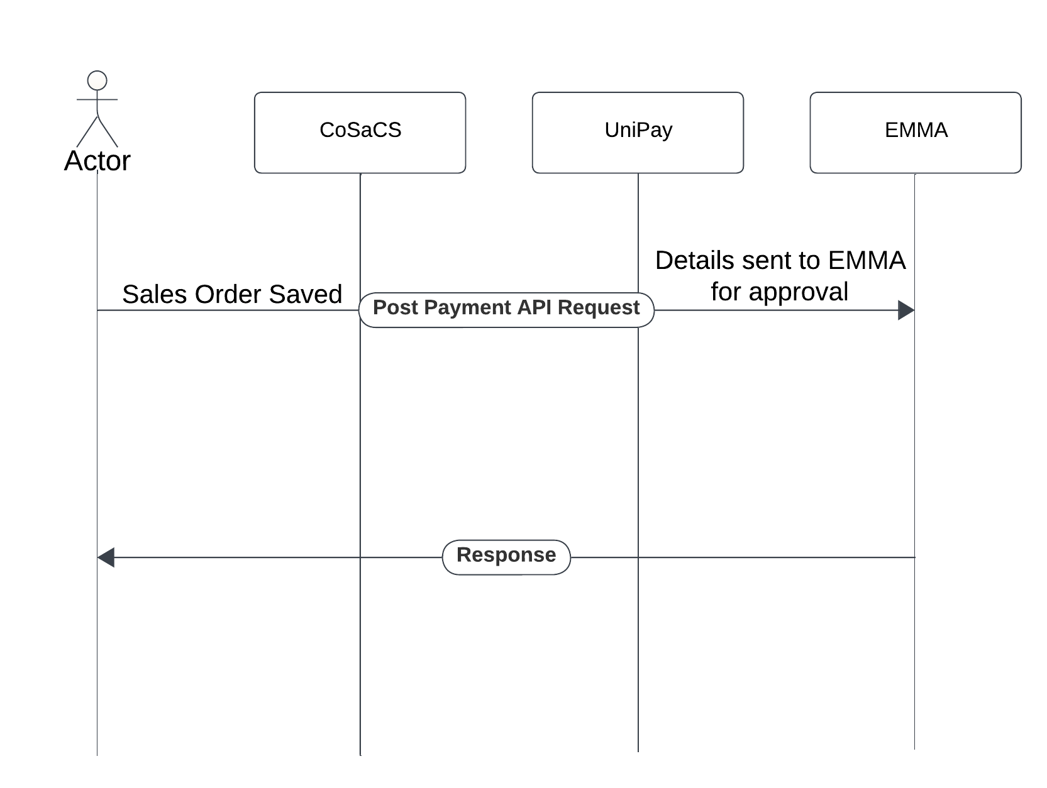

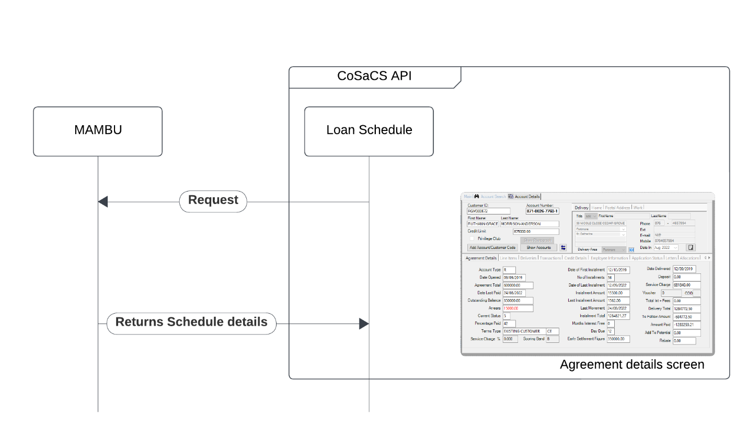

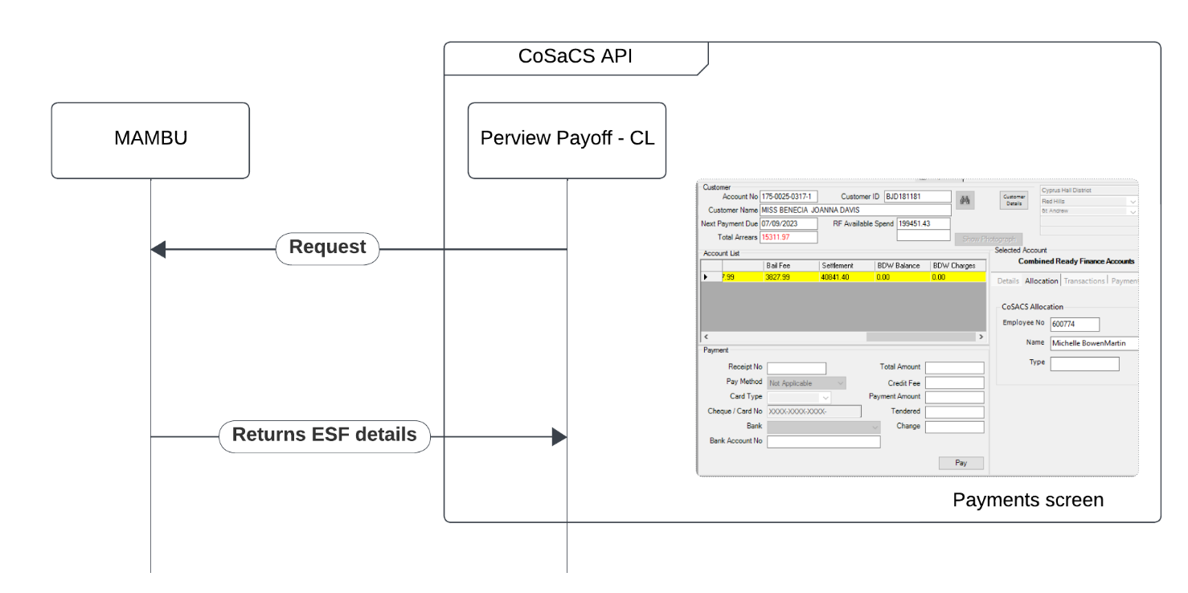

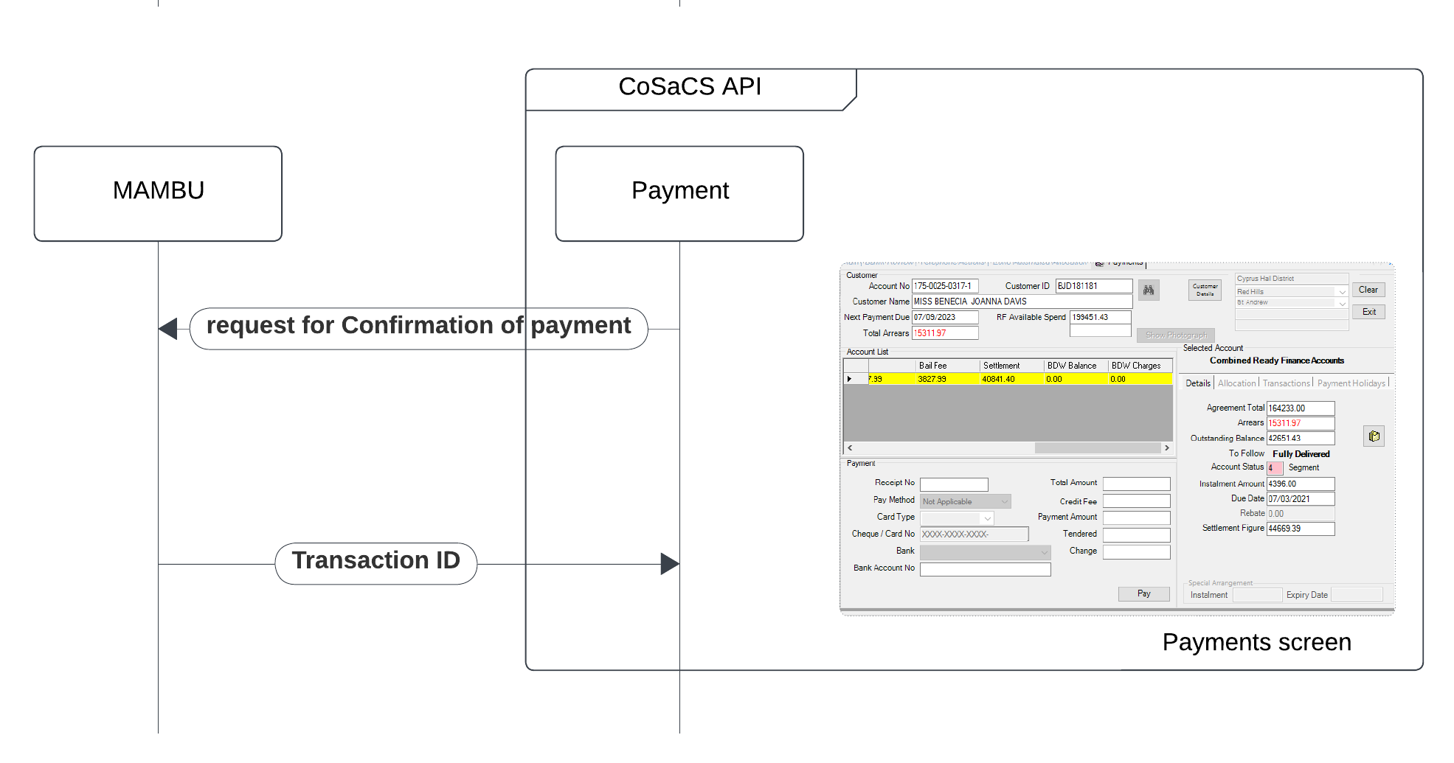

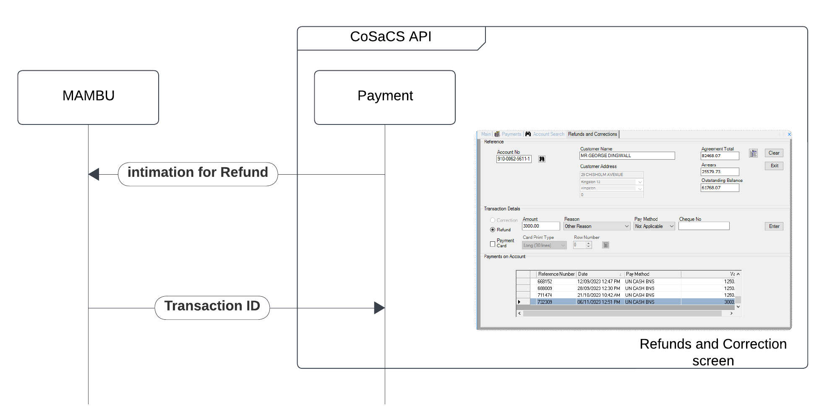

3.0 Detailed Solution oriented documentation

|  |
| --- |
| In this section we will elaborate the functional perspectives with greater detail. For example, configuration details, data diagram and code diagram. We will ask developer about the server name, database name, the connectivity type and its dependencies on other system  Wherever possible, we will ask developers to provide us inputs for connectivity type, technology name, version, for external systems of MoneyLine application for example. For,  - Universal Client System - DMZ Applications - Incapsula Load Balancer - Pension Master Online Web App |

4.0 Testing Scenarios

|  |
| --- |
| In this section we will include (attach) test plan for testing of Moneyline Application, sample test plan is attached in reference. In this section we can also attach test cases file along with textual use case for specific use case, if any. |